Mrs. Keri, Ms. Brenda, Mrs. Brooke & Ms. Kadee’s Weekly Buzz
October 18-22, 2021
Dates to Remember:
Oct. 11-15 FALL BREAK
October 25-29: red ribbon
week (See schedule below!)
October 29: Fall festival
November 11: veterans day parade
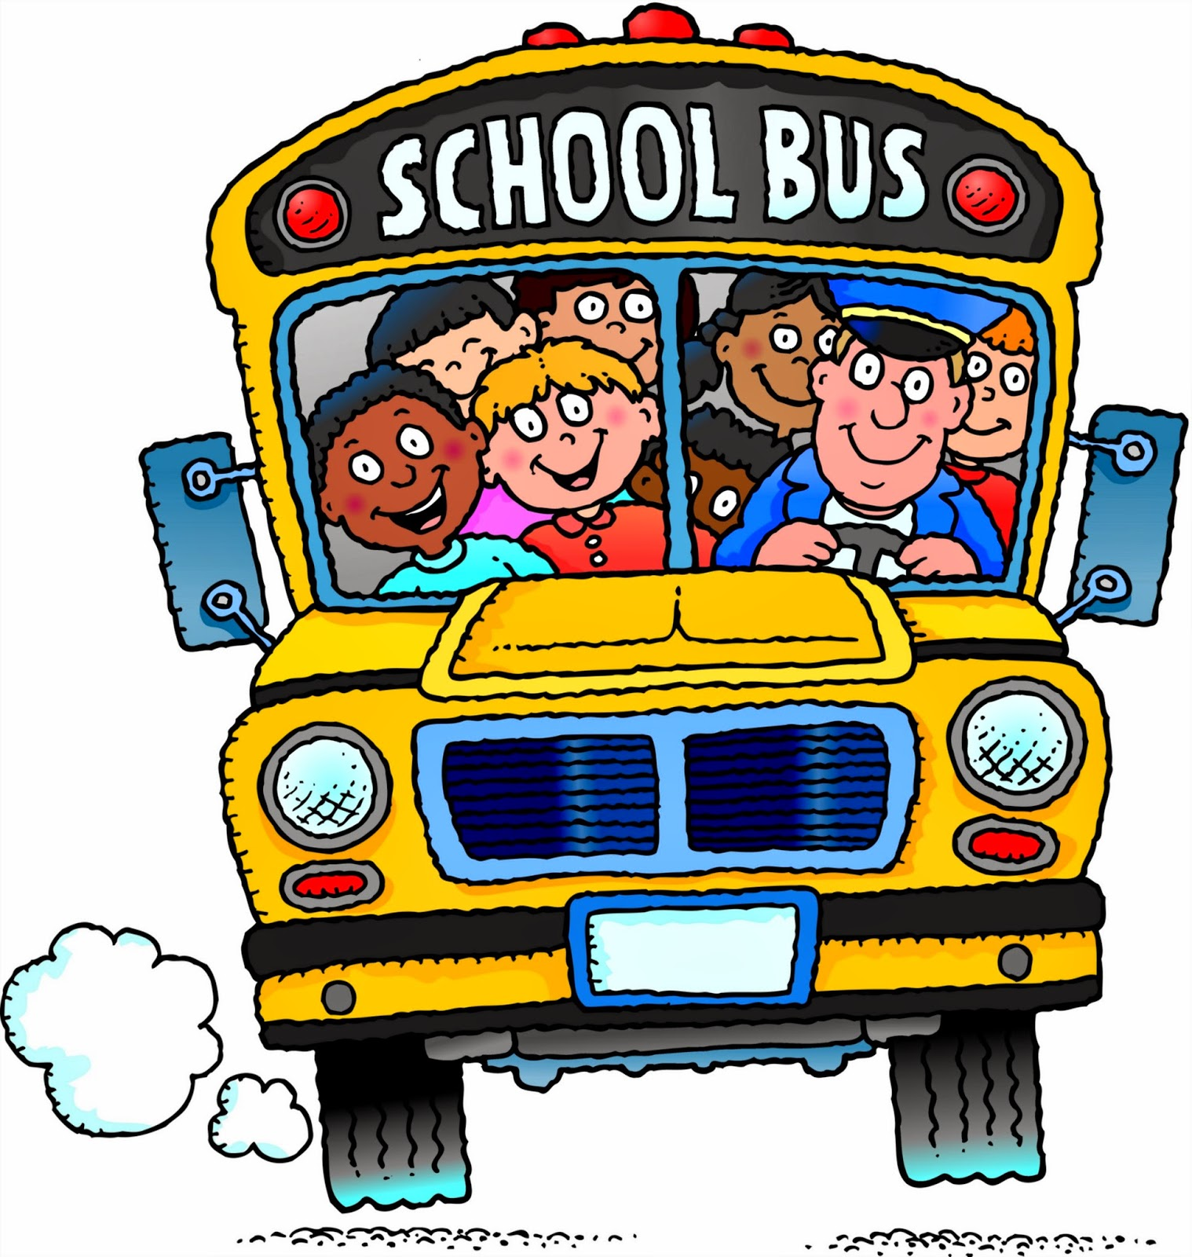

Quotes of the week
We are truly becoming a school family. I love their love for one another. Just a small example... This is a few answers to the question “what do you love about Raelyn?”
JoyAnna: “I like her beads in her hair.”
Sophie: “ I like to play with her.”
Leland: “ I like her bow in her hair.”
Eddie: “She is so sweet!”
Blakeley: “ She’s a good sister in our school family.”

Our Week In Review
Welcome back! We are so glad everyone seemed to have a nice restful Fall Break. We have enjoyed sharing our Fall Break Project bags with each other. Thanks for sending them back to school. This week we read one of our very most favorite books, Big Pumpkin. We illustrated the characters and wrote a sentence about which one we liked best. In math we played “Trouble” to work on counting 1:1 and we had a 2D & 3D shape race. Don’t forget to send in a bag of candy for our fall festival if you haven’t already.
Thank you!

This week’s sight words:
for are
RED RIBBON WEEK
Oct. 25-29

Monday: wear favorite team shirt
Tuesday: wear neon/bright colors
Wednesday: wear RED
Thursday: wear camouflage
Friday: costume (not scary)

What we’ve been reading…

Chrysanthemum
Vocabulary: wilted, appreciate

Big Pumpkin
Vocabulary: drat, weeded, boasted, snapped

